Notes Catanatron | BCollazo | How to install Docker

1a. Checking if docker is already installed:
(venv) PS C:\Users\***\GitHub Projects\catanatron-bcollazo> docker –version

Terminal Output:
(venv) PS C:\Users\***\GitHub Projects\catanatron-bcollazo> docker –version
docker : The term 'docker' is not recognized as the name of a cmdlet, function, script file, or operable program. Check the spelling of the name, or if a path was included, verify that the p ath is correct and try again. At line:1 char:1
- docker --version

+ CategoryInfo : ObjectNotFound: (docker:String) [], CommandNotFoundException + FullyQualifiedErrorId : CommandNotFoundException

1b. Installing docker:
If you want to review the game visually in the browser (recommended for AB games), install Docker first:
- Download Docker Desktop here: https://www.docker.com/products/docker-desktop/
- Run the installer (just click Next a few times).
- Restart your computer after installation.
- Open a new PowerShell window and run:
PowerShell
docker compose up
(Keep this window open.)

(catanatron) PS C:\Users\***\GitHub Projects\catanatron-bcollazo> docker compose up

Terminal Output:
(catanatron) PS C:\Users\***\GitHubProjects\catanatron-bcollazo> docker compose up
unable to get image 'postgres': Error response from daemon: Docker Desktop is unable to start What's next: Debug this Compose error with Gordon → docker ai "help me fix this compose error"

1c. Make sure docker is running:
Docker Desktop is installed on your machine, but it is not running (or failed to start). That’s why you get the “Docker Desktop is unable to start” error when trying docker compose up.
Quick Fix – Try These Steps (in order)
- Manually start Docker Desktop
  - Search for “Docker Desktop” in the Windows Start menu and open it.
  - Wait until it fully starts (the whale icon in the system tray turns green).
  - If it shows any setup wizard, complete it.
- Restart Docker Desktop
  - Right-click the Docker whale icon in the system tray → Restart.
  - Wait 10–20 seconds.
- Try again
PowerShell
docker compose up
If it still fails, do this:
- Restart your computer, then open Docker Desktop manually before running the command again.

1d. Update WSL:
Docker Desktop says WSL needs updating

✅ Got it — this is a very common Windows issue.
Docker Desktop needs the Windows Subsystem for Linux (WSL) to be updated before it can start the database.
Fix it in 2 minutes (follow exactly):
- Close Docker Desktop completely Right-click the Docker whale icon in the bottom-right system tray → Quit Docker Desktop.
- Open PowerShell as Administrator Right-click the Start button → Windows PowerShell (Admin) or Terminal (Admin).
- Run these two commands (copy-paste one by one and press Enter):
PowerShell
wsl --update
wsl --shutdown
- Restart Docker Desktop Open Docker Desktop from the Start menu and wait until the whale icon turns green and says “Docker Desktop is running”.
- Start the database + UI (in a new PowerShell window):
PowerShell
cd "C:\Users\***\GitHub Projects\catanatron-bcollazo"
docker compose up
Keep this window open.

1e. Try “docker compose up” again:
(catanatron) PS C:\Users\***\ GitHubProjects\catanatron-bcollazo> docker compose up

Terminal Output:
db-1 |
db-1 |
See https://github.com/docker-library/postgres/issues/37 for a (long)
db-1 | discussion around this process, and suggestions for how to do so.
react-ui-1 |
react-ui-1 | > ui@0.2.0 start
react-ui-1 | > vite
react-ui-1 |
db-1 exited with code 1
Container catanatron-bcollazo-db-1 Error dependency db failed to start
react-ui-1 |
react-ui-1 | VITE v6.3.5 ready in 540 ms
react-ui-1 |
react-ui-1 | ➜ Local: http://localhost:3000/
react-ui-1 | ➜ Network: http://172.18.0.3:3000/
dependency failed to start: container catanatron-bcollazo-db-1 exited (1)
What's next:cker Desktop o View Config w Enable Watch d Detach
Debug this Compose error with Gordon → docker ai "help me fix this compose error

1f. Fix PostgreSQL:
✅ This is a common Docker + PostgreSQL issue.
The error you’re seeing happens because the PostgreSQL Docker image was updated to version 18+, but there is old database data left in the volume from a previous version. The container refuses to start to avoid corruption.
Fix it with these two commands
Run them exactly in your project folder:
PowerShell
# 1. Stop everything and delete the old database volume
docker compose down -v

# 2. Start everything again (fresh database)
docker compose up
- Keep the docker compose up terminal window open (this runs the database + web UI).
- Open your browser and go to http://localhost:3000 (it should load once the containers are ready).

1f. Fix PostgreSQL in an alternative way:
✅ I see the exact same error again.
Even though you ran docker compose down -v, the PostgreSQL volume still contains old data from a previous version. The new Postgres image (v18+) refuses to start to avoid corrupting your data.
Fix it with these exact commands (copy-paste one by one):
PowerShell
# 1. Stop everything
docker compose down -v --remove-orphans

# 2. Remove the specific database volume (this is the key step)
docker volume rm catanatron-bcollazo_db_data

# 3. Start fresh
docker compose up
If step 2 says the volume does not exist, run this instead:
PowerShell
docker volume prune -f
docker compose up

Keep the docker compose up terminal open.
Once you see the db-1 container start successfully (no more error), refresh http://localhost:3000 in your browser.

1g. Fix PostgreSQL once again an alternative way:
Your UI container is fine. The failure is the Postgres container.
The key line is this:
There appears to be PostgreSQL data in:
/var/lib/postgresql/data (unused mount/volume)
That usually means your project’s Docker setup is now using a newer Postgres image, but an old persistent volume is still mounted with data laid out for the previous version. The new container refuses to start against that old data layout.

Fastest fix if you do not need old DB game history
Shut everything down and remove the old Postgres volume, then start fresh.
From the repo root:
docker compose down -v
docker compose up --build
That removes the persistent DB volume and recreates it cleanly.
If you only care about getting the GUI running now, this is the best first thing to try.

If you want to be a bit more targeted
You can first list volumes:
docker volume ls
Then remove the project’s Postgres-related volume only. It will likely have a name containing your folder/project name plus db or postgres.

Why this happens
Your DB volume contains old PostgreSQL files created by an earlier image/version. The current image expects the newer directory scheme and refuses to boot with the old one in the old location.
So this is not a Python or GUI problem. It is a stale Docker Postgres volume problem.

After that
Once docker compose up works, open:
http://localhost:3000

Bottom line, I had to edit the docker-compose.yml!

2. Edit docker-compose.yml
Change the db service volume from this:
volumes:
- ./db-data:/var/lib/postgresql/data
to this:
volumes:
- ./db-data:/var/lib/postgresql

3. Remove the old host folder contents
Because ./db-data already contains the old layout, you should delete or rename it before starting again.
From PowerShell in the repo root:
Rename-Item .\db-data db-data-old
or delete it if you do not care about old DB contents:
Remove-Item .\db-data -Recurse -Force

4. Start fresh
Then run:
docker compose down
docker compose up --build

What I expect after that
- db-1 should start successfully
- server-1 should come up
- react-ui-1 is already fine
- then http://localhost:3000 should work with the backend connected

(catanatron) PS C:\Users\***\GitHub Projects\catanatron-bcollazo> docker compose up --build

Terminal Output:
(catanatron) PS C:\Users\***\GitHub Projects\catanatron-bcollazo> docker compose up –build
…
Container catanatron-bcollazo-db-1 Healthy
server-1 | * Serving Flask app 'catanatron.web/catanatron.web'
server-1 | * Debug mode: on server-1 | WARNING: This is a development server. Do not use it in a production deployment. Use a production WSGI server instead.
server-1 | * Running on all addresses (0.0.0.0)
server-1 | * Running on http://127.0.0.1:5001
server-1 | * Running on http://172.18.0.4:5001
server-1 | Press CTRL+C to quit server-1 | * Restarting with stat
server-1 | * Debugger is active!
server-1 | * Debugger PIN: 117-155-227
v View in Docker Desktop o View Config w Enable Watch d Detach

Great — the backend is up now.
You have:
- DB healthy
- Flask server running on port 5001
- React UI already on port 3000
So the next step is simply:
http://localhost:3000
Open that in your browser.

Browser:
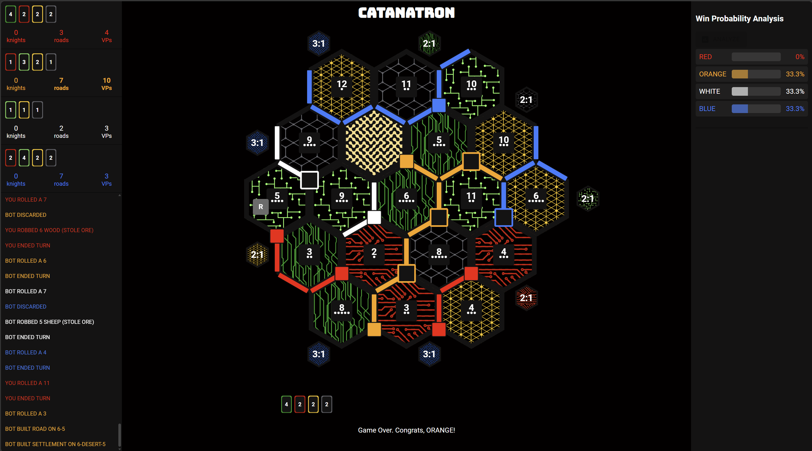

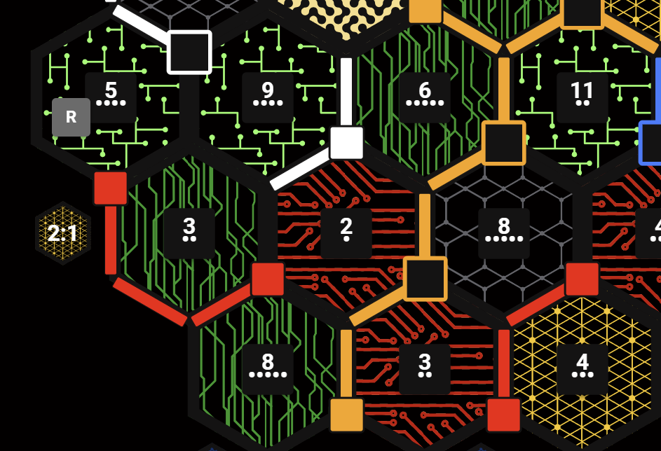

Legend:
- Green tiles having values 5 and 9, have tile_type = Pasture (sheep)
- Green tiles having having values 3,8 and 6, have tile_type = Forest (wood)
- Gray tile having having value 8, has tile_type = Mountain (ore)
- Yellow tile having having value 4, has tile_type = Field (wheat)
- Red tiles having having values 2 and 3, have tile_type = Hill (brick)

Important note
Because your compose file uses:
image: postgres
with no version pin, it will keep tracking the latest Postgres image, which is why this kind of breakage can happen.
A safer version would be to pin it, for example:
image: postgres:17
or another version you want to stay on.
So the more robust fix is:
db:
image: postgres:17
together with the volume path update.

Recommended final DB block
db:
image: postgres:17
environment:
- POSTGRES_USER=catanatron
- POSTGRES_PASSWORD=victorypoint
- POSTGRES_DB=catanatron_db
ports:
- 5432:5432
volumes:
- ./db-data:/var/lib/postgresql
healthcheck:
test:
[
"CMD-SHELL",
"pg_isready -d postgresql://catanatron:victorypoint@db:5432/catanatron_db",
]
interval: 5s
timeout: 5s
retries: 5

