Notes Catanatron | BCollazo | How to download the Catanatron code and use it

Prerequisites
- You have uv installed globally (run uv --version to confirm).
- You have git installed (for cloning).
- Python 3.8+ is available on your system (the project is from ~2020–2022 and uses Pygame, which works well on 3.8–3.11; newer versions like 3.12 should be fine too).

Step 1. I created a folder “catanatron-bcallazo” using Explorer:
C:\Users\***\GitHub Projects\catanatron-bcallazo

Step 2. I openend this new folder in VSCode myself:
PS C:\Users\***\GitHub Projects \catanatron-bcallazo>

Step 3. Run this exact command in your current terminal (PowerShell):
git clone https://github.com/bcollazo/catanatron.git .
The dot (.) at the end is important — it tells git to clone directly into the current folder (instead of creating a nested Catanatron subfolder).

Terminal Output:
PS C:\Users\***\GitHub Projects\catanatron-bcollazo> git clone https://github.com/bcollazo/catanatron.git .
Cloning into '.'...
remote: Enumerating objects: 8771, done.
remote: Counting objects: 100% (761/761), done.
remote: Compressing objects: 100% (149/149), done.
remote: Total 8771 (delta 660), reused 612 (delta 612), pack-reused 8010 (from 3)
Receiving objects: 100% (8771/8771), 47.85 MiB | 2.06 MiB/s, done.
Resolving deltas: 100% (5495/5495), done.

Step 4. Create venv (=virtual environment)
PS C:\Users\***\GitHub Projects\catanatron-bcollazo> python -m venv venv

Step 5. Activate venv (=virtual environment)
PS C:\Users\***\GitHub Projects\catanatron-bcollazo> .\venv\Scripts\Activate.ps1

Step 6. Install the package in editable mode
(venv) PS C:\Users\***\GitHub Projects\catanatron-bcollazo> pip install -e .

(venv) PS C:\Users\***\GitHub Projects\catanatron-bcollazo> pip install -e .
Obtaining file:///C:/Users/***/GitHub%20Projects/catanatron-bcollazo
Installing build dependencies ... done
Checking if build backend supports build_editable ... done
Getting requirements to build editable ... done
Preparing editable metadata (pyproject.toml) ... done
Collecting networkx (from catanatron==3.3.0)
Downloading networkx-3.6.1-py3-none-any.whl.metadata (6.8 kB)
Collecting click (from catanatron==3.3.0)
Downloading click-8.3.1-py3-none-any.whl.metadata (2.6 kB)
Collecting rich (from catanatron==3.3.0)
Using cached rich-14.3.3-py3-none-any.whl.metadata (18 kB)
Collecting colorama (from click->catanatron==3.3.0)
Using cached colorama-0.4.6-py2.py3-none-any.whl.metadata (17 kB)
Collecting markdown-it-py>=2.2.0 (from rich->catanatron==3.3.0)
Using cached markdown_it_py-4.0.0-py3-none-any.whl.metadata (7.3 kB)
Collecting pygments<3.0.0,>=2.13.0 (from rich->catanatron==3.3.0)
Using cached pygments-2.19.2-py3-none-any.whl.metadata (2.5 kB)
Collecting mdurl~=0.1 (from markdown-it-py>=2.2.0->rich->catanatron==3.3.0)
Using cached mdurl-0.1.2-py3-none-any.whl.metadata (1.6 kB)
Downloading click-8.3.1-py3-none-any.whl (108 kB)
Using cached colorama-0.4.6-py2.py3-none-any.whl (25 kB)
Downloading networkx-3.6.1-py3-none-any.whl (2.1 MB)
━━━━━━━━━━━━━━━━━━━━━━━━━━━━━━━━━━━━━━━━ 2.1/2.1 MB 2.5 MB/s 0:00:00
Using cached rich-14.3.3-py3-none-any.whl (310 kB)
Using cached pygments-2.19.2-py3-none-any.whl (1.2 MB)
Using cached markdown_it_py-4.0.0-py3-none-any.whl (87 kB)
Using cached mdurl-0.1.2-py3-none-any.whl (10.0 kB)
Building wheels for collected packages: catanatron
Building editable for catanatron (pyproject.toml) ... done
Created wheel for catanatron: filename=catanatron-3.3.0-0.editable-py3-none-any.whl size=16039 sha256=c15bd765c80118fce5c572622b4f079eabc3052c9e10a445511bd964ca2f3d49
Stored in directory: C:\Users\***\AppData\Local\Temp\pip-ephem-wheel-cache-6gx093j0\wheels\34\80\7a\ea9eeb9e87ee2e9175ffd7c6e80154c0341ca769cfe8b56210
Successfully built catanatron
Installing collected packages: pygments, networkx, mdurl, colorama, markdown-it-py, click, rich, catanatron
Successfully installed catanatron-3.3.0 click-8.3.1 colorama-0.4.6 markdown-it-py-4.0.0 mdurl-0.1.2 networkx-3.6.1 pygments-2.19.2 rich-14.3.3

[notice] A new release of pip is available: 25.2 -> 26.0.1
[notice] To update, run: python.exe -m pip install --upgrade pip

Step 7. Quick smoke test – run a small simulation; try one of the basic examples from the README:
catanatron-play --players=R,R,R,W --num=20

Terminal Output:
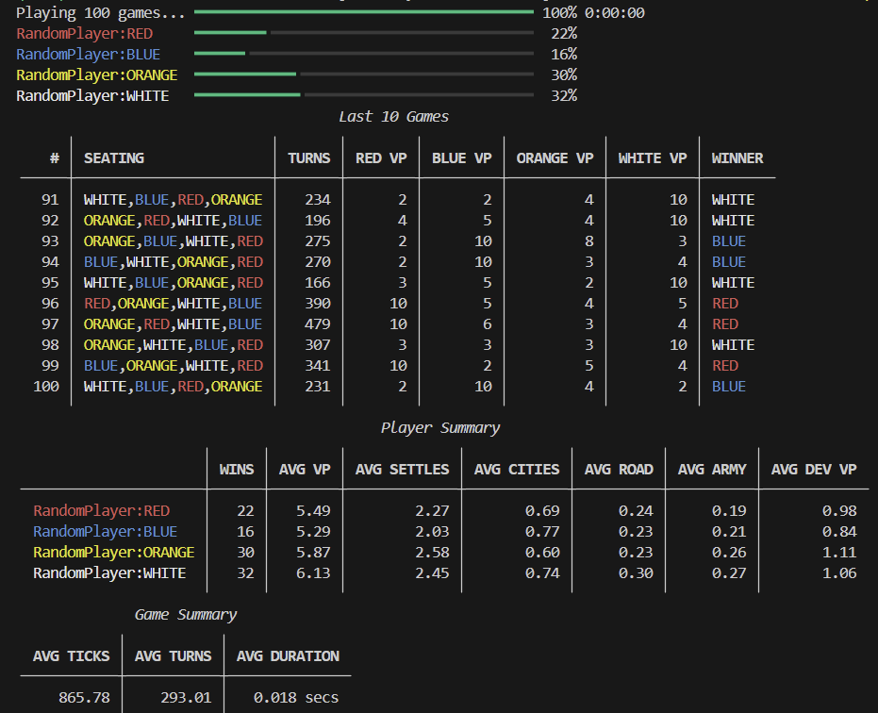

Alternatively smoke test in Python (optional but nice to verify import + game loop) creating a script called quick_test.py in your project folder:

Python
from catanatron import Game, RandomPlayer, Color

players = [
RandomPlayer(Color.RED),
RandomPlayer(Color.BLUE),
RandomPlayer(Color.WHITE),
RandomPlayer(Color.ORANGE),
]

game = Game(players)
winner = game.play() # runs the full game
print(f"Winner: {winner}")

# Correct way to get turns played
print(f"Turns played: {game.state.num_turns}")

Run it:
python quick_test.py

You should now see something like:
Winner: Color.WHITE
Turns played: 68
(The exact number varies per game, but it's usually 50–100+ turns in 4-player random games.)

Other useful things you can inspect on game.state after play()
Here are some commonly accessible read-only attributes (based on the API docs and typical usage):
- game.state.num_turns → total turns completed
- game.state.victory_points → dict of Color → int (final VPs for each player)
- game.state.resource_counts → dict of Color → dict of Resource → count
- game.state.board → the board object (with methods/attrs like .roads, .settlements, .cities, .robber_pos, etc.)
- game.state.played_dev_cards → list of dev cards that were played
- game.state.actions → full log of every action taken (very detailed)
- game.state.current_player → the player who would act next (usually irrelevant after game ends)

Example additions to print more stats:
Python
# ... after game.play()

print(f"Winner: {winner}")
print(f"Turns played: {game.state.num_turns}")

print("\nFinal Victory Points:")
for color, vp in game.state.victory_points.items():
print(f" {color}: {vp}")

print("\nFinal resource counts (example for winner):")
winner_resources = game.state.resource_counts[winner]
for res, count in winner_resources.items():
print(f" {res}: {count}")

This will give you a nice post-game summary.

Quick tips
- The game can end in slightly different ways (normal 10 VP, or very rarely special conditions), but play() returns the winning Color.
- If you want to run many games and collect stats (e.g. average turns, win rates), use the CLI instead — it's much faster:
PowerShell
catanatron-play --players=R,R,R,R --num=500
It prints aggregated results including average turns per game.
- For deeper exploration: check dir(game.state) in a Python shell to list all available attributes, or look at the source/docs: https://catanatron.readthedocs.io/en/latest/catanatron.html#module-catanatron.state

